Case Study: 9
Name: Urwashi Dhawas PRN: 24070521154
Title: To design and implement a Student Registration Status Management System using HTML, CSS, JavaScript, and JSON to add, manage, search, and track student registrations as Done, Pending, or Cancelled.
Software/Tools Required: VSC, HTML, CSS, JavaScript
Case Study program code:
index.html:
<!DOCTYPE html>
<html lang="en">

<head>
<meta charset="UTF-8">
<meta name="viewport" content="width=device-width, initial-scale=1.0">

<title>Student Registration System</title>

<link rel="stylesheet" href="style.css">
</head>

<body>

<div class="container">

<header>
<h1>Student Registration System</h1>
<p>Manage student registration status</p>
</header>

<!-- Dashboard -->

<section class="dashboard">

<div class="card">
<h3>Total Students</h3>
<p id="totalCount">0</p>
</div>

<div class="card done">
<h3>Done</h3>
<p id="doneCount">0</p>
</div>

<div class="card pending">
<h3>Pending</h3>
<p id="pendingCount">0</p>
</div>

<div class="card cancelled">
<h3>Cancelled</h3>
<p id="cancelledCount">0</p>
</div>

</section>

<!-- Add Student -->

<section class="form-section">

<h2>Register New Student</h2>

<form id="studentForm">

<input
type="text"
id="studentId"
placeholder="Student ID"
required
>

<input
type="text"
id="studentName"
placeholder="Student Name"
required
>

<input
type="text"
id="course"
placeholder="Course"
required
>

<input
type="email"
id="email"
placeholder="Email"
required
>

<input
type="date"
id="date"
required
>

<select id="payment">
<option value="Paid">Paid</option>
<option value="Pending">Pending</option>
<option value="Refunded">Refunded</option>
</select>

<select id="status">
<option value="Done">Done</option>
<option value="Pending">Pending</option>
<option value="Cancelled">Cancelled</option>
</select>

<button type="submit">
Add Student
</button>

</form>

</section>

<!-- Search and Filter -->

<section class="controls">

<input
type="text"
id="search"
placeholder="Search by ID or name..."
>

<select id="statusFilter">

<option value="All">All Status</option>

<option value="Done">
Done
</option>

<option value="Pending">
Pending
</option>

<option value="Cancelled">
Cancelled
</option>

</select>

</section>

<!-- Student Table -->

<section class="table-section">

<h2>Student Registrations</h2>

<table>

<thead>

<tr>
<th>ID</th>
<th>Name</th>
<th>Course</th>
<th>Email</th>
<th>Date</th>
<th>Payment</th>
<th>Status</th>
<th>Action</th>
</tr>

</thead>

<tbody id="studentTable">

</tbody>

</table>

</section>

</div>

<script src="script.js"></script>

</body>

</html>

Style.css:
* {
margin: 0;
padding: 0;
box-sizing: border-box;
}

body {
font-family: Arial, sans-serif;
background: #f4f6f9;
color: #333;
}

.container {
width: 95%;
max-width: 1400px;
margin: 30px auto;
}

/* Header */

header {
background: #1f3c88;
color: white;
padding: 25px;
border-radius: 10px;
margin-bottom: 25px;
}

header h1 {
margin-bottom: 8px;
}

/* Dashboard */

.dashboard {
display: grid;
grid-template-columns: repeat(4, 1fr);
gap: 20px;
margin-bottom: 25px;
}

.card {
background: white;
padding: 25px;
border-radius: 10px;
box-shadow: 0 3px 10px rgba(0, 0, 0, 0.08);
}

.card h3 {
margin-bottom: 10px;
}

.card p {
font-size: 30px;
font-weight: bold;
}

.done p {
color: green;
}

.pending p {
color: orange;
}

.cancelled p {
color: red;
}

/* Form */

.form-section {
background: white;
padding: 25px;
border-radius: 10px;
margin-bottom: 25px;
}

.form-section h2 {
margin-bottom: 20px;
}

form {
display: grid;
grid-template-columns: repeat(4, 1fr);
gap: 15px;
}

input,
select {
padding: 12px;
border: 1px solid #ccc;
border-radius: 6px;
font-size: 14px;
}

button {
padding: 12px 18px;
border: none;
border-radius: 6px;
background: #1f3c88;
color: white;
cursor: pointer;
font-weight: bold;
}

button:hover {
background: #162d68;
}

/* Controls */

.controls {
display: flex;
justify-content: space-between;
gap: 15px;
margin-bottom: 20px;
}

.controls input {
flex: 1;
}

.controls select {
width: 200px;
}

/* Table */

.table-section {
background: white;
padding: 25px;
border-radius: 10px;
overflow-x: auto;
}

.table-section h2 {
margin-bottom: 20px;
}

table {
width: 100%;
border-collapse: collapse;
}

th,
td {
padding: 13px;
text-align: left;
border-bottom: 1px solid #ddd;
}

th {
background: #1f3c88;
color: white;
}

tr:hover {
background: #f5f5f5;
}

/* Status */

.status {
padding: 6px 10px;
border-radius: 15px;
font-size: 12px;
font-weight: bold;
}

.status-done {
background: #d4edda;
color: #155724;
}

.status-pending {
background: #fff3cd;
color: #856404;
}

.status-cancelled {
background: #f8d7da;
color: #721c24;
}

/* Action buttons */

.update-btn {
background: #198754;
margin-right: 5px;
}

.delete-btn {
background: #dc3545;
}

.update-btn:hover {
background: #146c43;
}

.delete-btn:hover {
background: #bb2d3b;
}

/* Responsive */

@media (max-width: 900px) {

.dashboard {
grid-template-columns: repeat(2, 1fr);
}

form {
grid-template-columns: repeat(2, 1fr);
}

}

@media (max-width: 600px) {

.dashboard {
grid-template-columns: 1fr;
}

form {
grid-template-columns: 1fr;
}

.controls {
flex-direction: column;
}

.controls select {
width: 100%;
}

}
Script.js:
let students = [];

// ========================================
// LOAD DATA FROM JSON
// ========================================

fetch("students.json")
.then(response => response.json())
.then(data => {

students = data.students;

displayStudents();

updateDashboard();

})
.catch(error => {

console.log("Error loading JSON:", error);

// If JSON cannot be loaded, try localStorage

const savedStudents =
localStorage.getItem("students");

if (savedStudents) {

students = JSON.parse(savedStudents);

displayStudents();

updateDashboard();

}

});

// ========================================
// DISPLAY STUDENTS
// ========================================

function displayStudents() {

const table =
document.getElementById("studentTable");

table.innerHTML = "";

const searchValue =
document
.getElementById("search")
.value
.toLowerCase();

const filterValue =
document
.getElementById("statusFilter")
.value;

const filteredStudents = students.filter(student => {

const matchesSearch =
student.id.toLowerCase().includes(searchValue) ||
student.name.toLowerCase().includes(searchValue);

const matchesStatus =
filterValue === "All" ||
student.status === filterValue;

return matchesSearch && matchesStatus;

});

filteredStudents.forEach(student => {

const row =
document.createElement("tr");

let statusClass = "";

if (student.status === "Done") {

statusClass = "status-done";

}
else if (student.status === "Pending") {

statusClass = "status-pending";

}
else if (student.status === "Cancelled") {

statusClass = "status-cancelled";

}

row.innerHTML = `

<td>${student.id}</td>

<td>${student.name}</td>

<td>${student.course}</td>

<td>${student.email}</td>

<td>${student.date}</td>

<td>${student.payment}</td>

<td>

<span class="status ${statusClass}">
${student.status}
</span>

</td>

<td>

<button
class="update-btn"
onclick="updateStatus('${student.id}')"
>
Update
</button>

<button
class="delete-btn"
onclick="deleteStudent('${student.id}')"
>
Delete
</button>

</td>

`;

table.appendChild(row);

});

}

// ========================================
// ADD STUDENT
// ========================================

document
.getElementById("studentForm")
.addEventListener("submit", function(event) {

event.preventDefault();

const id =
document.getElementById("studentId").value;

const name =
document.getElementById("studentName").value;

const course =
document.getElementById("course").value;

const email =
document.getElementById("email").value;

const date =
document.getElementById("date").value;

const payment =
document.getElementById("payment").value;

const status =
document.getElementById("status").value;

// Check duplicate ID

const exists =
students.some(student =>
student.id === id
);

if (exists) {

alert("Student ID already exists!");

return;

}

const newStudent = {

id: id,

name: name,

course: course,

email: email,

date: date,

status: status,

payment: payment

};

students.push(newStudent);

// Save to browser storage

localStorage.setItem(
"students",
JSON.stringify(students)
);

displayStudents();

updateDashboard();

alert(
"Student registration added successfully!"
);

document
.getElementById("studentForm")
.reset();

});

// ========================================
// UPDATE STATUS
// ========================================

function updateStatus(id) {

const student =
students.find(student =>
student.id === id
);

if (!student) {

return;

}

const newStatus =
prompt(
"Enter status:\nDone\nPending\nCancelled",
student.status
);

if (!newStatus) {

return;

}

const formattedStatus =
newStatus.charAt(0).toUpperCase() +
newStatus.slice(1).toLowerCase();

if (
formattedStatus !== "Done" &&
formattedStatus !== "Pending" &&
formattedStatus !== "Cancelled"
) {

alert(
"Invalid status! Use Done, Pending or Cancelled."
);

return;

}

student.status = formattedStatus;

// Update payment automatically

if (formattedStatus === "Done") {

student.payment = "Paid";

}
else if (formattedStatus === "Cancelled") {

student.payment = "Refunded";

}
else {

student.payment = "Pending";

}

localStorage.setItem(
"students",
JSON.stringify(students)
);

displayStudents();

updateDashboard();

alert("Status updated successfully!");

}

// ========================================
// DELETE STUDENT
// ========================================

function deleteStudent(id) {

const confirmation =
confirm(
"Are you sure you want to delete this registration?"
);

if (!confirmation) {

return;

}

students =
students.filter(student =>
student.id !== id
);

localStorage.setItem(
"students",
JSON.stringify(students)
);

displayStudents();

updateDashboard();

}

// ========================================
// DASHBOARD COUNTS
// ========================================

function updateDashboard() {

const total =
students.length;

const done =
students.filter(student =>
student.status === "Done"
).length;

const pending =
students.filter(student =>
student.status === "Pending"
).length;

const cancelled =
students.filter(student =>
student.status === "Cancelled"
).length;

document.getElementById("totalCount")
.textContent = total;

document.getElementById("doneCount")
.textContent = done;

document.getElementById("pendingCount")
.textContent = pending;

document.getElementById("cancelledCount")
.textContent = cancelled;

}

// ========================================
// SEARCH
// ========================================

document
.getElementById("search")
.addEventListener(
"input",
displayStudents
);

// ========================================
// FILTER
// ========================================

document
.getElementById("statusFilter")
.addEventListener(
"change",
displayStudents
);
Output:
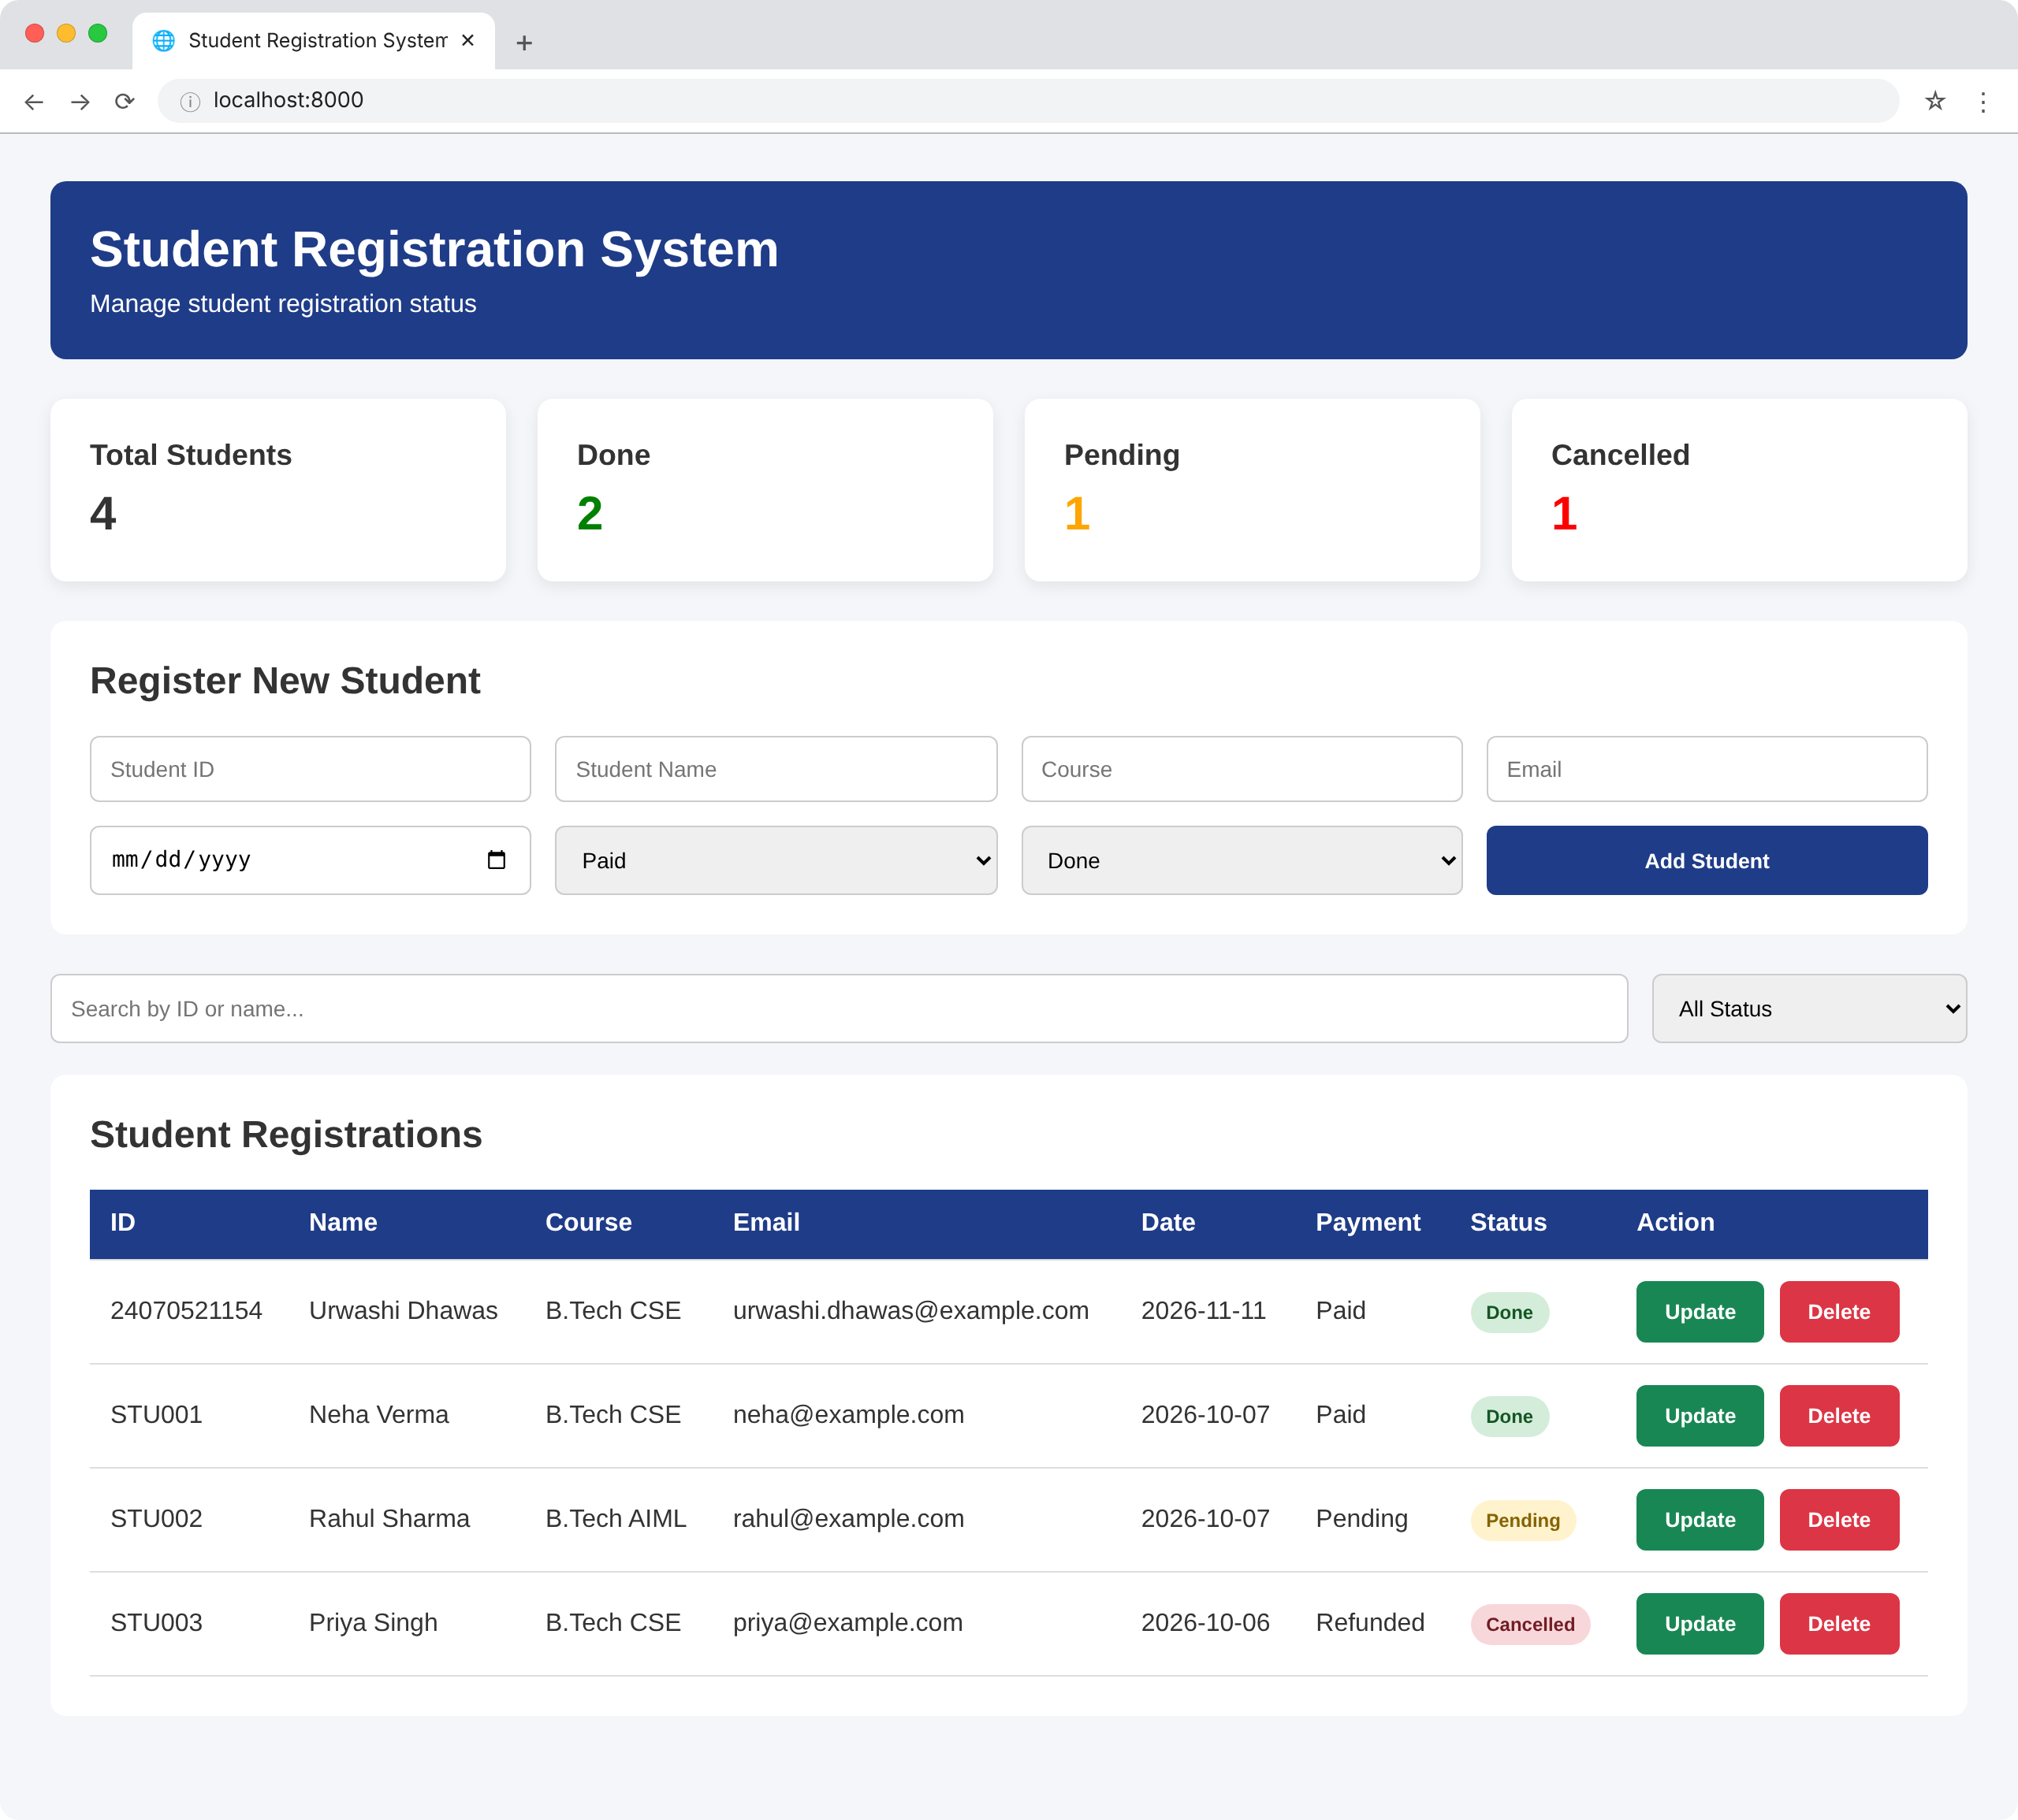

RESULT:
The Student Registration Status Management System was successfully implemented. It can add student records and display, search, filter, update, and delete registrations based on their Done, Pending, or Cancelled status.

